

MATH-H407: Control System Design

Laboratory experiment

The Centrifugal Ring Positioner

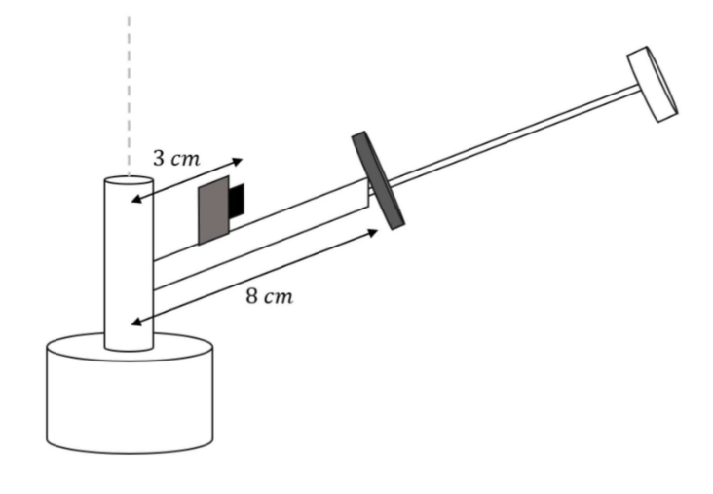

|  |  |
| --- | --- |
| *Group 26– Electrical Engineering* | *Professor* |
| * Hicham Alla * Alexis Bollengier * Ethan Fack * Maxime Firrincieli | Emanuele Garone |
| *Teaching Assistants* |
| Maxime Bussios  Frank Mukwege |

# Table of Content

Table of Content 2

Introduction 3

Instrumentation 3

Sensors 3

Actuators 3

Anti-Aliasing Filter 3

System Identification 4

DC Motor Identification 4

Gray Box Approach and Transfer Function 4

Translation of Radians per Second into the corresponding Output 6

Ring Position Identification 7

Translation of Output into Meters 7

Controller 8

Choice of Control Schemes 8

Design of PD Controller 9

Design of LQI Controller 10

Alternative to LQI controller 11

Simulink Simulations for Controller Design 12

Simulink for motor 12

Simulink for LQI 12

Simulink of Complete System 13

Simulation Results of Simulink 13

Conclusions on the use of Simulink 13

Results 14

Step Response 14

Sine Wave Response 15

Overview of the motor’s ability to follow the desired speed 16

Effect of steps on the motor 16

Effect of sine wave on motor 17

Effect of dead zone and saturation 17

Possible Future Improvements 18

Conclusion 18

# Introduction

In this lab, we analyze a centrifugal ring positioner system, which consists of a ring that slides on a tilted rod connected to a rotating shaft. The main objective of this system is to control the position of the ring along the rod using centrifugal force. By controlling the rotational speed of the motor, the ring’s position can be adjusted to achieve a desired setpoint. LTI models are derived for both the DC motor and the ring’s position and simulated using Simulink together with their discrete controllers. These were also validated on the real plant to design the control system. The primary goal is to stabilize the ring at a specific position along the rod, thus minimizing static error. Additionally, a more advanced objective involves controlling the position of the ring such that it follows a sinewave as closely as possible.

# Instrumentation

The centrifugal ring positioner system uses several sensors and actuators to monitor and control the ring’s movement. The key components are:

## Sensors

* **Optical Incremental Encoder (Velocity Sensor)**: This sensor is used to measure the rotational speed of the motor shaft. By monitoring the angular velocity, the system can determine the centrifugal force applied to the ring, which is essential for controlling its position.
* **Infrared Sensor (Position Sensor)**: Positioned 3 cm from the rotational axis of the rod, this sensor measures the position of the ring along the rod. This information is crucial for feedback control, allowing for adjustments to the motor speed to reach the desired position. A part of the datasheet was provided to convert its output into centimeters.

## Actuators

* **DC Motor**: The system is driven by a current-controlled DC motor, specifically a Maxon RE25 gear motor, which has the following characteristics:
  + Diameter: 25 mm
  + Voltage: 24 VDC
  + Power: 10 W
  + Torque Constant: 43.9 mNm/A
  + Reduction Ratio (ηg): 35.

The DC motor provides the necessary force to rotate the rod, thereby influencing the ring’s position through centrifugal force. By controlling the energy supplied to the motor, the rotational speed can be adjusted to move the ring along the rod.

## Anti-Aliasing Filter

After consulting the teaching assistant he told us that a sampling at a rate above 100 Hz would be complicated to obtain once the complete controller was in place. We thus decided to use an anti-aliasing filter with a cut-off frequency at 40 Hz and sampled at 100 Hz such that frequencies that were not attenuated enough had no aliasing effect on the lower frequencies.

# System Identification

The system which must be controlled is made of two subsystems. The first subsystem is the motor, for which we can derive the equations and thus use the gray box approach to determine its transfer function. The second subsystem is the position of the ring given its distance from the center, its speed and the rotation speed of the rod. For this second subsystem all necessary parameters were given such that a white box approach can be used.

## DC Motor Identification

First, we need to identify the working range of the DC motor. By incrementing the input to the motor we can identify at which point the motor starts rotating and up to what point an increase of rotational speed is measured. Conducting these tests, the following results were found:

|  |  |
| --- | --- |
| Lower limit of the dead zone | -1.75 |
| Higher limit of the dead zone | 1.7 |
| Speed saturation | -8.42 |
| Speed saturation | 8.30 |

In the future, we will assume that this unitless input to the motor is proportional to the voltage over the motor. The effect of the dead zone and the saturation speed will be explained later.

### Gray Box Approach and Transfer Function

fffff
As a reminder, the gray box approach involves identifying the coefficients of a physical model by combining equations with real measurements of the system. This method allows us to compute a transfer function linking the input of the motor to the angular velocity without knowing the coefficients of the physical model. *Figure 1* shows us that we can use Kirchhoff’s law to derive the necessary equations.

*Figure 1: Scheme of the DC Motor equivalent circuit*

1. **Kirchhoff’s law**

where:

* is the input voltage
* is the inductance (assumed negligible)
* is the resistance
* is the armature current
* is the back electromotive force constant
* is the angular velocity

This equation allows us to link indirectly the motor’s input and the back electromotive force with . Some of these coefficients influence each other (f.e. torque and armature current), making their computation difficult. This is the reason why we chose the gray box approach.

1. **Mechanical equation**

where:

* is the torque
* is the inertia of the rotor
* is the viscous friction coefficient
* is the load torque

As previously said, the torque is related to the armature current via this relation:

where is the torque constant of the DC motor. By substituting from the electrical equation into this one, dividing by and taking the Laplace Transform, we know which coefficients we need to estimate to find the transfer function of the motor:

where:

To fit these parameters, we used the following methodology:

1. We applied a step from the slowest speed possible that made the ring move to its outer saturation point, to a speed arbitrarily higher but in the region we expected the motor to be used the most. This was done to avoid any perturbation caused by the ring.
2. The input and output were recorded and put into a MATLAB script.
3. The code of this MATLAB script constructs a transfer function using our guess for the parameters as starting point. This is a first guess of our model.
4. The response of the model to the input is simulated using the MATLAB function ***lsim***.
5. We then use Mean Squared Error to compute the difference between our simulated model and our measurements
6. The optimization process in the MATLAB function ***fminsearch*** iteratively minimizes the error to refine the parameters

This procedure allowed us to compute the following analytic transfer function:

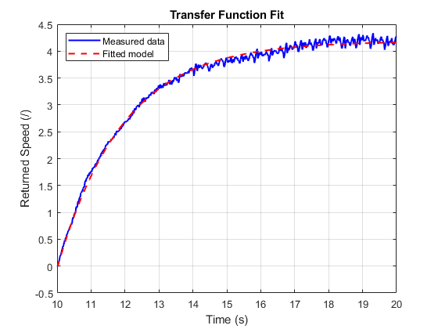This is the transfer function from the input, that we assumed to be proportional to the voltage, to the rotational speed. The step response compared to the measured data can be seen in *Figure 2*. Note that the speed was shifted down to account for the non-zero starting input.

*Figure 2: Step response of the model (red) compared to the measured data (blue)*

### Translation of Radians per Second into the corresponding Output

Once the transfer function of the motor was determined, we made a very crude first estimate of a PID controller. This controller had as only objective to keep the error as small as possible between the output we got from the system, representing the rotational speed and a certain desired output. Once the motor was stabilized around this set point, we could determine the rotations per second of the motor for a given input. This was measured multiple times on multiple different desired outputs over a wide range but more precisely around the lower speeds as we expected the motor to be used the most in this region. Using these measurements, a linear fit through the origin was done to determine what factor should be used to translate rad/s into the output of the system. We got a constant of:

This translation step was necessary because our white box approach to the system of ring’s position meant that specific units were used to calculate the linearized equations. These units carry on as being used for the control in later stages thus translation was necessary to be able to calculate the error between the desired output and the measured output in the same units.

## Ring Position Identification

The ring experiences multiple forces while rotating. The centrifugal force pulls the ring away from the center while the gravitational force pulls it back towards the center. In addition to that, friction will slow down the ring for a high velocity. After writing out the set of equations describing these forces we get the following equation for the ring’s acceleration:

The values of the constants are:

Interestingly, if we consider the ring to have a stationary position, we get the following equations for the rotational speed for a given distance:

This equation gives the equilibrium points of our system. We can remark that for a greater distance, a smaller rotational speed is necessary but to get to this greater distance, a rotational speed increase is necessary. To determine the state-space from the above equation, we linearize around a given point using the following values:

After derivation and inputting the linearization point, we get the following matrices:

These are the matrices for the continuous time state-space. We must remark that in reality the ring has two saturation points; the lower one at 8 cm from the rotating axis and the upper one at 19 cm from the rotating axis. We will discuss the effect of these saturation points later.

### Translation of Output into Meters

As part of the given characteristics about the distance sensor, a translation chart was given translating a certain distance into a specific output voltage. These points were then meticulously put in a MATLAB matrix, and a fitting function was applied. Multiple functions were tested but the functions that best fitted the data was the sum of two exponentials. Even though we would expect a function of 1/x or 1/x² to predict the data, this sum of exponentials was used as it gave the best fitting to the datapoints. In other words, we prioritized accuracy over the data points rather than following a given model, because many intermediary steps could have an impact on the very simplistic model of 1/x or 1/x². An additional constant factor of 3 *cm* is added to account for the position of the sensor compared to the rotating axis. However, after testing this function by comparing its output with a measurement, we measured very big differences. We thus manually measured multiple points along the rod and calculated a new function based on the same fit function described above. We got the following translation function with an R² of 0.9985:

This translation function with the used data points is displayed in *Figure 3*. Note the fact that it steeply increases towards higher distances. This means that a noisy measurement could induce very big changes in the translated distance.

*Figure 3: Plot of translation function with the used datapoints*

# Controller

Given the nature of the two subsystems, the relatively slow ramp-up of the motor for a constant input, a very noisy and prone to perturbations output for the rotational speed and the sensitive nature of the rotational speed to the position of the ring, we decided to use a cascade controller to control the system. The inner loop of the controller would only control the motor to approach and maintain a given rotational speed. While the outer loop uses the ring’s position as feedback to calculate the required rotational speed needed to keep the ring at the desired setpoint. This approach was preferred as it idealizes the motor as something that follows a given rotational speed quite well without the outer loop needing to worry about any disturbances affecting the motor.

## Choice of Control Schemes

The control scheme is designed with a hierarchical structure to address the system dynamics effectively. The motor is controlled using a PD controller; the D action should make it possible for the motor to change more quickly, while the P action should avoid having too much of a constant error. The constant error that may occur due to the lack of an integrator will be cared for by the outer loop because the controller for the ring position implements an integrator.

To control the ring position, we opted for an LQI controller. This controller implements an optimal state-feedback controller with an integrator at the input. In this case, the input is the error between the ring position and the desired position. This controller guarantees a low constant error compared to the reference due to the presence of the integrator. Additionally, it can be tuned to better control for position or speed, which can be useful as part of the additional assignment is to follow a changing reference.

## Design of PD Controller

Due to the noisy output of the system on the rotational speed, a lead compensator was added to the D action of the PD. This will avoid having too much reaction on the high frequencies. In contradiction to this first necessity is the fact that we need the motor to react as fast as possible which indicates we want a big reaction on a rapidly varying input. The P action must then also be used to not have too big of an error for a constant input such that only small disturbances would have to be considered by the controllers. In addition, the delay due to the ZOH must also be considered during the design. The following form for the PD controller was used:

With ():

|  |  |
| --- | --- |
|  |  |
|  |  |

This form was derived from the continuous time PD controller with lead compensator in the Laplace domain and discretized using Tustin. This discretization technique was used as it offers the best results for low frequencies which we expect since we sample at 100 Hz. This discretization technique also preserves stability which is a useful characteristic. Due to the low frequencies, no pre-distortion was used for this discretization.

To design this PD controller, an iterative approach was used to test the effect of the different parameters: , and . The effects were observed by looking at the simulated step-response, talud-response (linearly increasing reference) and pole-placement of the whole system obtained after calculating the equivalent transfer function of the closed loop system. This means the transfer function of the motor, the discrete equivalent of the ZOH and the PD-controller were taken into account in the simulation. These three plots were used to theoretically optimize the parameters for getting the output as fast as possible to the reference while avoiding oscillations and following a linearly increasing input. The results can be seen in *Figure 4*, notice the small delay before the step and talud response due to the ZOH. Given the transfer function of the controller in the Z-domain we obtain the following difference equation:

This equation is both easier and more efficient to implement in code which is why it was derived.

*Figure 4: Simulated step response (left) and talud response (right) of the controlled model.*

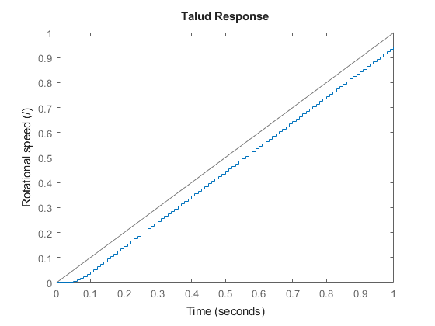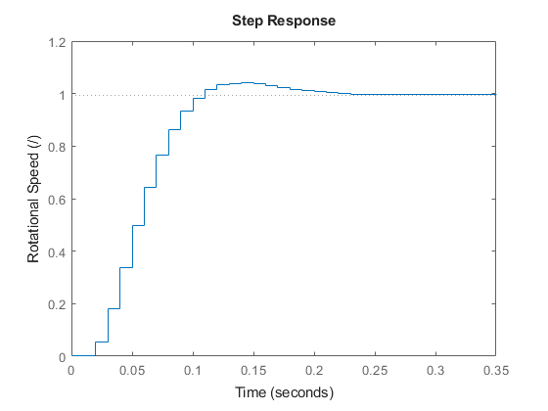

## Design of LQI Controller

To compute the LQI controller with MATLAB, we first have to define an extended version of the state. The first two values of this extended state are those of the system, being the position and speed of the ring. The last value represents the value returned by the integrator. The following extended state is thus obtained:

The speed was approximated using the following difference formula:

We also determined the discretized system using the **c2d** MATLAB function with discretization method “ZOH”. Just like an LQR, two matrices and have to be defined. The matrix represents the weights we give to the energy of the error of the different parts of the state. Increasing, for example, the weight of the distance part of the state compared to the speed part would create a controller very sensitive to the position while not taking the speed of the ring too much into consideration. The second matrix represents the energy of the input, the higher this weight, the more the energy taken from the input is minimized. It can thus be used to reduce the effect of the integrator on the controller. To compute the state-feedback gain matrices, the **lqi** MATLAB function was used together with the discretized system. After multiple simulations where the frequency response of the closed loop system with an idealized motor was optimized and observing the position of the ring such that saturation is avoided, the following and matrices were obtained:

The following gain matrices were then computed:

These gain matrices were then implemented in the control loop shown in *Figure 5*.

+

System

(A, B, C)

-

N

State estimation

K

+

+

rd

r

e

eI

u

x

ZOH

uc

*Figure 5: LQI control loop*

As you can see the weight chosen for the speed part of the state is much higher than that for the position. This was done as it minimized oscillations in the step response of the real system while still obtaining a good frequency response for sine wave oscillations. Due to the fact that the speed of a step is zero. By computing the closed loop frequency response of the controlled system with an idealized motor, we get the frequency response in *Figure 6*. The LQI was designed in such a way that a decent gain and phase margin were obtained while still following the reference very closely up to the highest possible frequency. The obtained phase margin is 53.7 deg and the gain margin is 18.2 dB. These were enough according to our experiments to account for any additional poles not accounted for due to the linearization, originating from the non-linearity of the system. There is also a resonance peak at about 1.3 rad/s and then a steep drop off in both phase and amplitude. This peak has an amplitude of 3.5 dB.

*Figure 6: Frequency response of closed loop system with LQI controller and idealized motor*

## Alternative to LQI controller

After some discussion with the teaching assistant, he told us that PIDs were used in the past and that we would be the first group to opt for another type of controller. This choice was made for different reasons. First of all, LQI is relatively easy to implement as it only requires to decide the weights of the Q and R matrices and the optimal control algorithm will make the system stable and asymptotically follow the reference for a good choice of weights. Additionally, designing a PID would take a lot of time to place the poles and zeros such that we obtain a stable system with the desired behavior. This process could also be very unintuitive compared to chosing how important a certain error is compared to another in the extended state. Lastly, using an LQI was a learning experience as it was the first time we used this technique and thus made it more interesting instead of placing poles and zeros.

# Simulink Simulations for Controller Design

To make the design of the controllers possible even when we could not get access to the plant, multiple Simulink simulations were made to simulate different parts of the system. This allowed fast iterations on the different parts of the controller.

## Simulink for motor

The Simulink for the motor was created to test the effect of a noisy reference while still being able to follow the desired speed in addition to testing the effect of the dead zone and the saturation. The used Simulink can be found in *Figure 7*. This simulation does not include the speed translation used to go from rad/s to the outputted value as this has no effect on the motor’s behavior.

*Figure 7: Simulink for motor*

## Simulink for LQI

To test multiple and matrices at a fast rate and get an intuition on the effect of the different weights, a Simulink was built to simulate the LQI control loop. This simulation idealized the motor but considers the possible effects of the motor’s saturation and dead zones. The used Simulink can be found in *Figure 8*. The translation of the returned value by the distance sensor to the actual distance was not taken into account since we could not model the sensor.

*Figure 8: Simulink for LQI controller*

## Simulink of Complete System

At last a Simulink of the complete system was created to try to incorporate all the effects of the system and its controller. This Simulink has multiple subsystems that incorporate the controllers described above. It also takes into account the translation of the desired speed of the LQI controller to the motor’s output value. The used Simulink can be found in *Figure 9*. This simulation was particularly useful as it took some non-idealities of the motor into consideration which made the final controller better suited for the real system.

*Figure 9: Simulink for the complete system with translation stage*

## Simulation Results of Simulink

The results of the Simulink simulating the complete system are visible in *Figure 10*. This simulation was done by first letting the ring position settle around the linearization point and then applying a step of 3 cm. As we can see there is an overshoot of approximately 1 cm and then the position oscillates for a few seconds. It takes the ring about 5.5 seconds to settle on the new setpoint.

**r (m)**

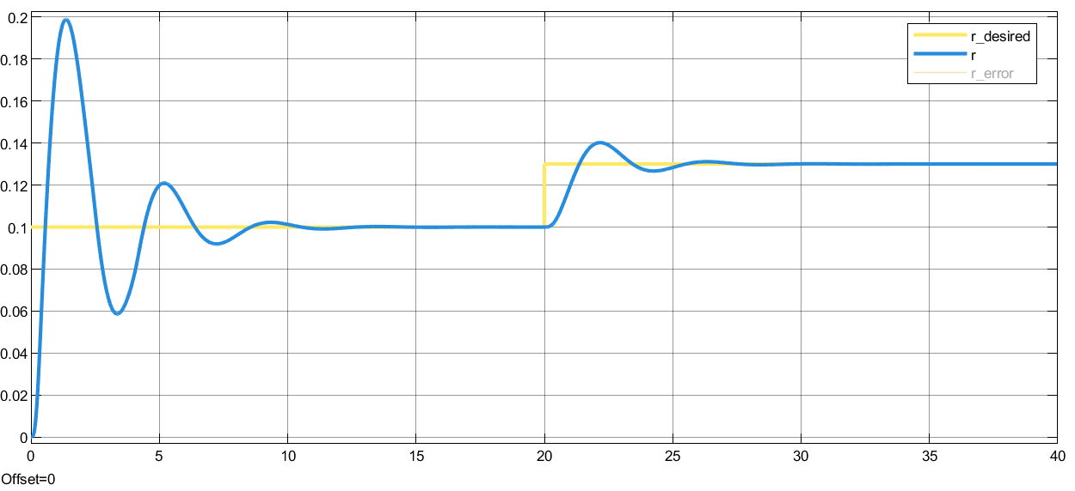

**Simulink Step Response of the ring’s position**

**Time (s)**

*Figure 10: Simulation of the ring’s position for a step*

When applying a sinusoidal signal with a frequency of 1 rad/s to the simulated system with an amplitude of 3 cm and a bias of 13 cm from the rotating axis, we get the results in *Figure 11*. As was predicted by the theoretical frequency response given in *Figure 6,* the amplitude has increased to 4 cm, i.e. an increase of 2.5 dB. There is also a delay of approximately 0.75 s. This delay is lower for smaller frequencies, it is mainly caused by the phase shift at this frequency.

When observing the response of the simulated motor compared to the desired rotation speed for the sine wave in *Figure 12*, we can notice that the simulated motor follows the desired speed very well with an error less than 0.1 rad/s in steady state. No noticeable phase occurs. We can note some small non-linearities due to the dead zone of the motor.

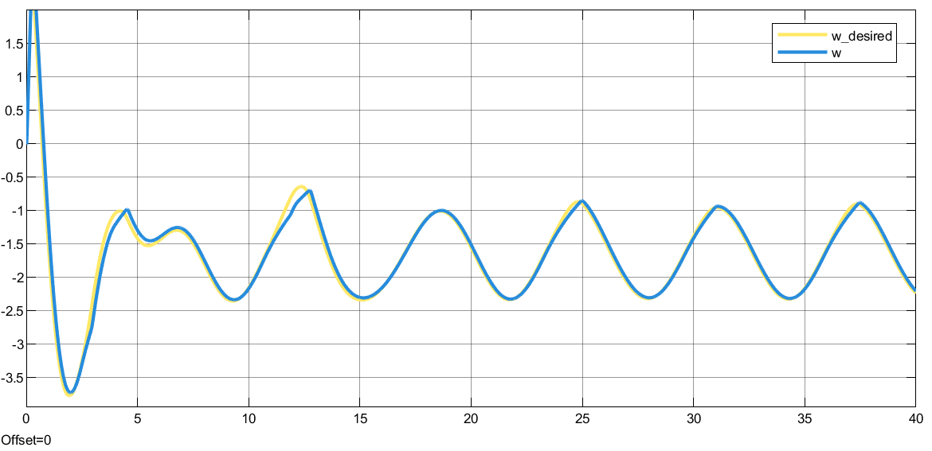

**Output Motor (/)**

**Simulink effect sine wave on Motor**

**Time (s)**

*Figure 12: Simulation of the motor’s response to a sinusoidal reference*

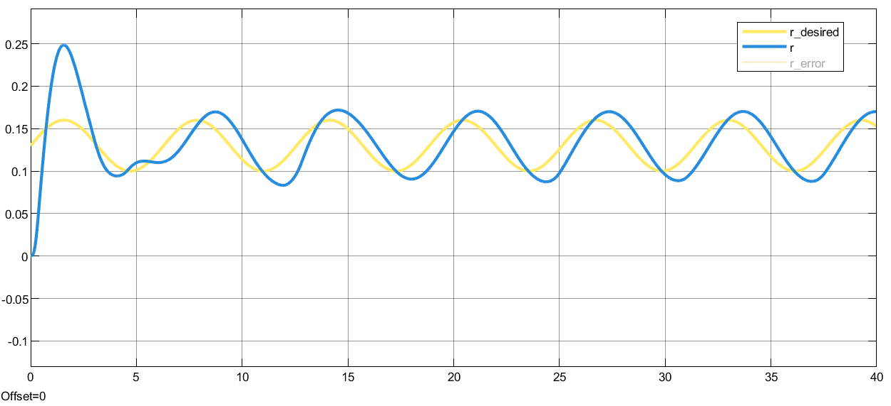

**r (m)**

**Simulink sine wave Response of the ring’s position**

**Time (s)**

*Figure 11: Simulation of the ring’s position for a sinusoidal reference*

## Conclusions on the use of Simulink

Although the Simulink simulations were very useful for fast iterations to determine a good range for the different values, they were not a complete replacement for the real system. Many non-idealities were not taken into account by these simulations like for example the static friction of the ring against the rod which increases the necessary force before a movement is observed. Another non-ideality is the time varying response of the motor on a given input due to the motor heating up for example. It was thus still necessary to confirm the effectiveness of the controller on the real system.

# Results of the test on the real plant

At first we measured the step response of the system. This was done by first letting the system settle at its linearization point and then applying a step to a few centimeters further. Later on we also measured the system’s response on a sine wave at different frequencies. In this case we also first let the system settle at its linearization point. This was done to work as closely as possible with the same parameters as were used for the linearization during the derivation of the state space equations.

## Step Response

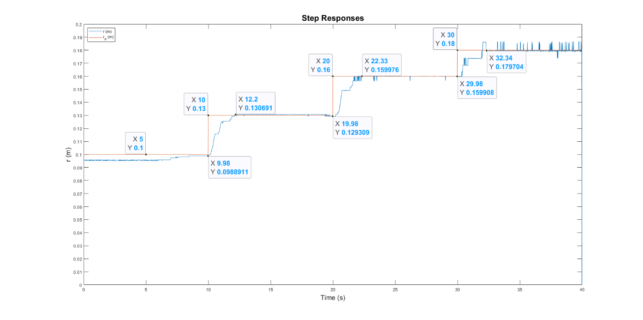After letting the system settle around its linearization point and applying a step after 10 s, then a second step at 20 s and a third step at 30 s, we obtained the measurements in *Figure 13*.

*Figure 13: Step responses at 10 s, 20 s and 30 s after settling*

The settling time of the first step after 10 s with an amplitude of 3 cm is about 2.24 s. The second step with an amplitude of 3 cm at 20 s has a settling time of 2.35 s. The last step at 30 s has a settling time of 2.26 s for an amplitude of 2 cm. All these steps have a constant error of less than a millimeter which is well beyond the error we can expect from the sensor and the translation function, which is only an approximation of the actual distance based on the sensor’s output which is prone to noise. We can also observe very big spikes when the mass is at 18 cm. This was to be expected as the translation function is very steep at that point which makes the translation very sensitive to noise.

## Sine wave Response

The response of the controlled system was measured at multiple frequencies for a sine wave with an amplitude of 3 cm. The theoretical frequency response of the controlled system with an idealized motor is repeated in *Figure 14*. You may want to use *Figure 6* as it is bigger.

*Figure 14: Frequency response of closed loop system with LQI controller and idealized motor*

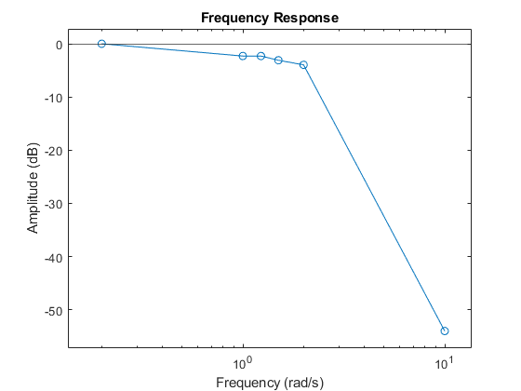After applying multiple frequencies, the frequency response in *Figure 15* was obtained.

*Figure 15: Frequency response of the controlled system at multiple frequencies*

As expected, for low frequencies under 0.2 rad/s the amplitude of the obtained sine wave is equivalent to the desired amplitude. For higher frequencies above 2 rad/s, the sine wave starts to decrease sharply in amplitude. Although we expected an increase in amplitude at 1.3 rad/s, no peak was observed. The -3 dB point is at about 1.5 rad/s. The theoretical -3 dB point is at about 2 rad/s. Additionally, the theoretical amplitude is at, or above 0 dB for all frequencies under 1.8 rad/s. These differences may be explained by the delay of approximately 0.8 s measured between the desired position and the moment it is obtained. This delay is approximately the same at a frequency of 0.2 rad/s to a frequency of 1.5 rad/s, after which we do not have any more meaningful data points as the amplitude of the sine wave at 10 rad/s is too small to determine the delay with certainty. This delay may be due to the delay of the ZOH combined with the overall slowness of the system due to, for example, friction. The different controllers could also create a phase shift. The addition of all these factors could thus explain the total delay of about 0.8 s. Additional poles due to the non-linearity of the system could also explain the lower amplitude. An overview of the sine wave responses can be found in *Figure 16*.

## Overview of the motor’s ability to follow the desired speed

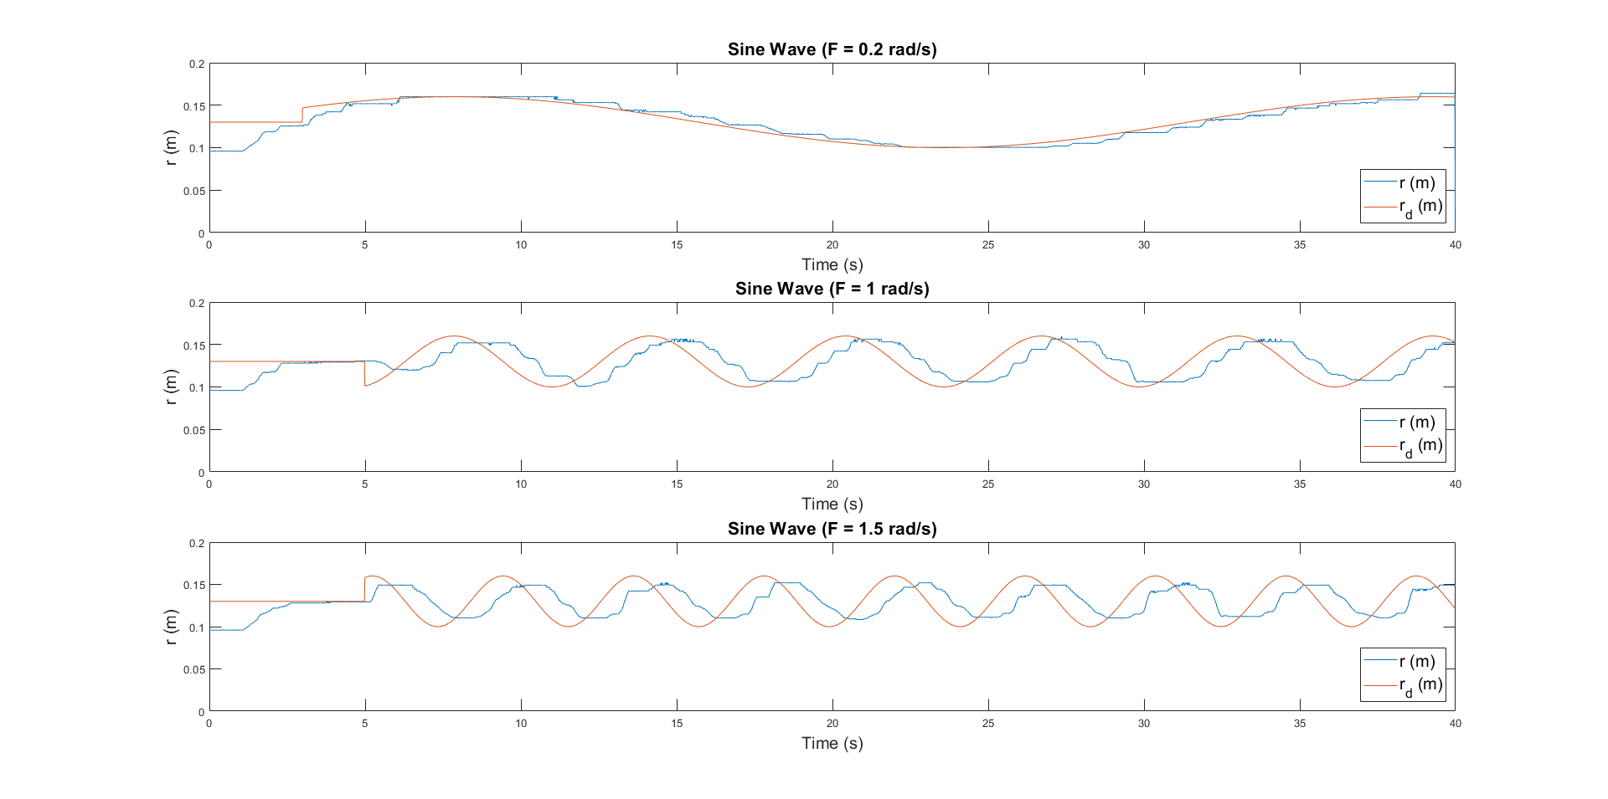

*Figure 16: Overview of the response of the controlled system at multiple frequencies*

By looking at the graphs describing the motor's speed translated in rad/s compared to the desired speed, we can determine whether the motor’s controller could be the source of the delay observed for the sine wave response.

### Effect of steps on the motor

First we will take a look at how the motor and the controller behaved for the step responses. In *Figure 17* we can see the motor’s response compared to the desired speed. As we can see, the desired speed becomes very noisy for the later steps. This is because of the distance increase and the very steep translation function at those distances. From what we see, the error between the desired speed and the actual speed is about 0.1 rad/s. Although this is relatively small, this could lead to the delay observed in the sine wave response of the ring’s position. This error was also observed in the Simulink simulations. Since this error is pretty constant over the complete measurement this may have been resolved by adding an integrator. We can although note that since this error remains constant, the motor follows the desired output relatively well.

*Figure 17: Overview of the motor’s response compared to the desired speed for multiple steps*

### Effect of sine wave on motor

As we can see in *Figure 18*, the motor follows the desired speed very well. There is a constant error but it is less than 0.5 rad/s. This means that although there is a small constant error this should not be a significant reason for the delay observed in the sine wave responses for the ring’s position.

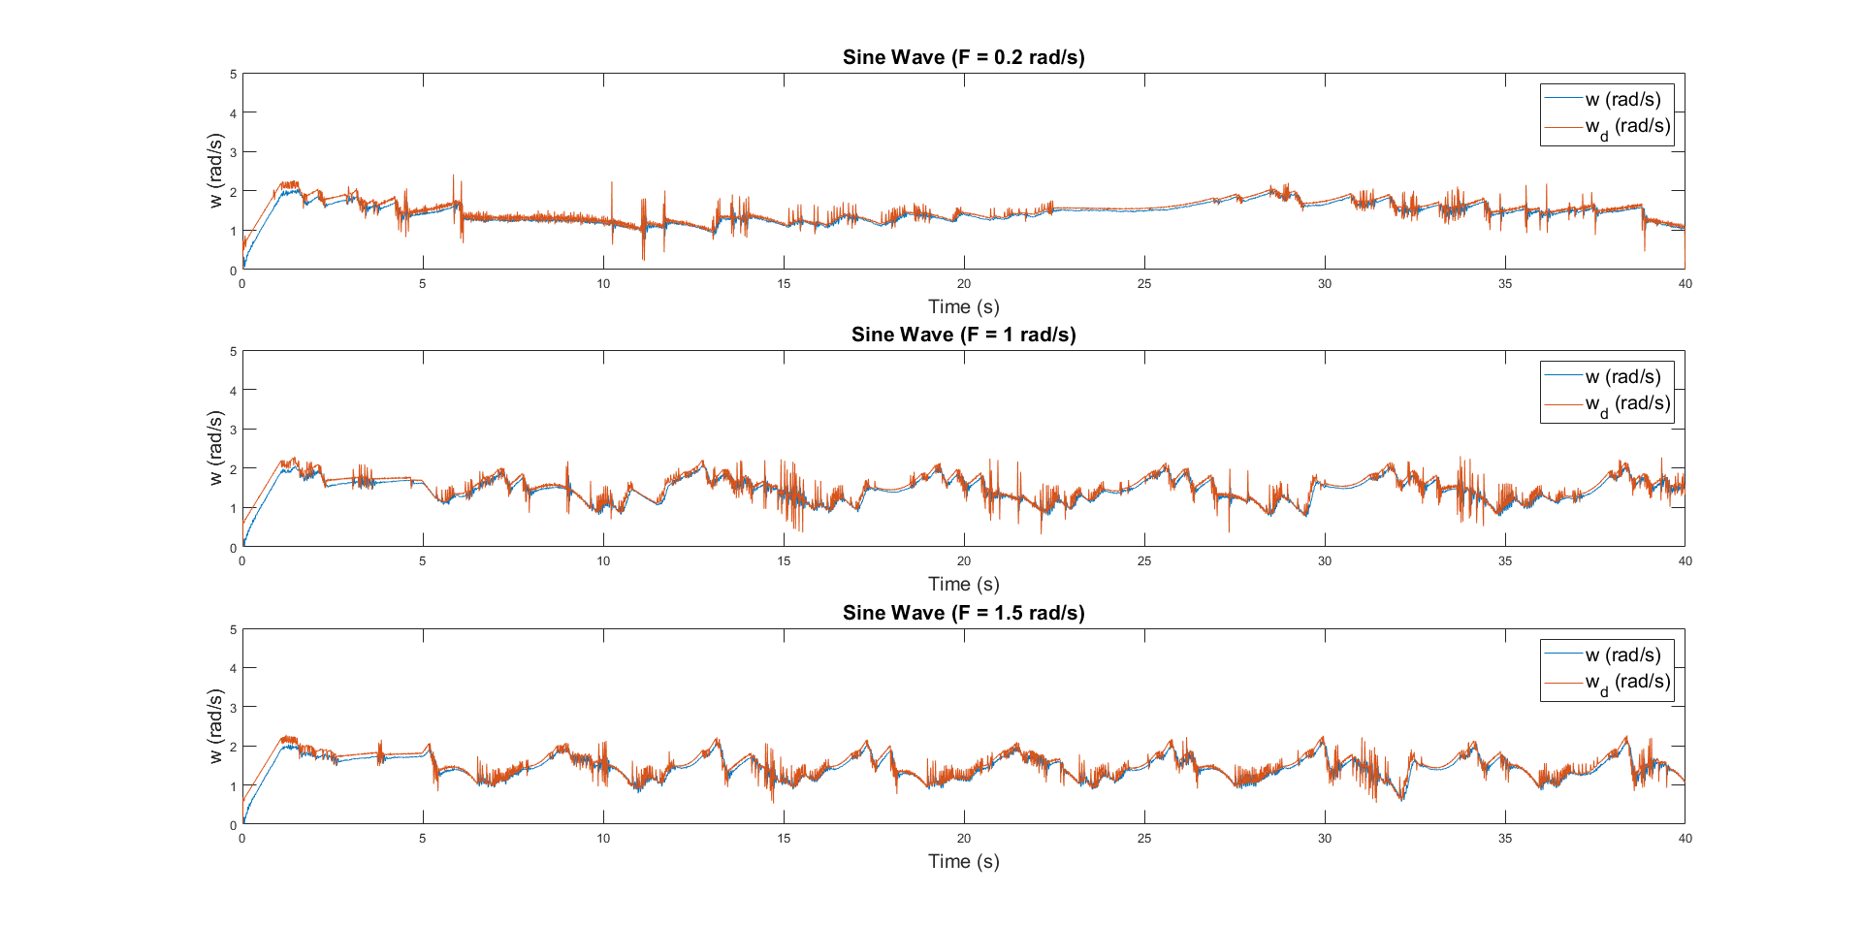

*Figure 18: Overview of the motor’s response compared to the desired speed*

## Effect of dead zone and saturation

From our experiments we can conclude that the saturation of the ring’s position has no effect on the stability of the system as long as the refence remains inside the reachable range. If the ring’s position saturates at the outer point, it has a stabilizing effect as the centrifugal force stops increasing (for a constant rotation speed) and thus the controller can bring the ring back to the desired position. If the desired position is outside of this range, the integrator will experience wind up. In the case where the ring saturates at the inner saturation point, another phenomenon may occur. This saturation to the inner point is only possible if the set point is too low or that the motor is not rotating. In the case where the set point is too low, this creates wind up of the integrator and ends up making the motor turn in the opposite direction which destabilizes the controlled system. To avoid this, two options are possible; either clamp the set point between the reachable values or detect in some way that the motor is turning in the wrong direction and reset the integrator.

The motor’s saturation had no effect on the stability of the system as it was seldom reached and very low rotations speeds are generally used to position the ring. High rotation speeds are only used briefly to reposition the ring to a further distance but from the measured data we cannot conclude any effect from the saturation speed of the motor. The dead zone’s effect was minimized thanks to the PD controller managing the motor’s input.

## Possible Future Improvements

By increasing the sampling rate, and having less friction between the ring and the rod, a faster response could be obtained after adapting the model of the new system and optimizing the Q and R weighting matrices to these new conditions. A more powerful motor could also make it possible to speed up and slow down more quickly which could increase the speed at which the controller can control the ring’s position and thus having a better frequency response at higher frequencies. Other control schemes to control the ring’s position could also be more appropriate for a changing reference. The addition of an integrator to the motor’s controller could maybe remove the constant error we observed in the analysis of the motor’s ability to follow the desired speed. Lastly, a more accurate distance sensor and translating function could remove any physical error in the position of the ring compared to the measured position.

# Conclusion

To control the given system we chose to use a cascade controller. The first controller implemented an LQI that was responsible for controlling the ring’s position. This controller was chosen for its ease of implementation and its intuitive design approach. The integrator would also eliminate any constant error in the ring’s position. The second controller implemented a PD controller with a lead compensator to avoid noise affecting the returned input too much. This controller was chosen as we needed the motor to follow the desired input quickly, without being affected by noise.

Using these controllers we managed to obtain a step response with a settling time of less than 2.35 seconds for a step amplitude of 3 cm. The constant error was less than 1 mm which is well beyond the expected precision of the sensor and the translation function combined. The controller managed to follow the sine wave responses relatively well with an amplitude drop of less than -3 dB for a frequency under 1.5 rad/s. A relatively constant delay of about 0.8 s was observed over all the frequencies up to 2 rad/s. This may be due to the to the delay of the ZOH combined with the overall slowness of the system due to, for example, friction. The different controllers could also create a phase shift. The addition of all these factors could thus explain the total delay of about 0.8 s. Additional poles due to the non-linearity of the system could also explain the lower amplitude.

In conclusion, we were thus able to achieve the requirement of minimizing the error on a step reference without any oscillations and were also able to follow a sine wave reference with a slight drop in amplitude and a small delay.